QUESTION 1
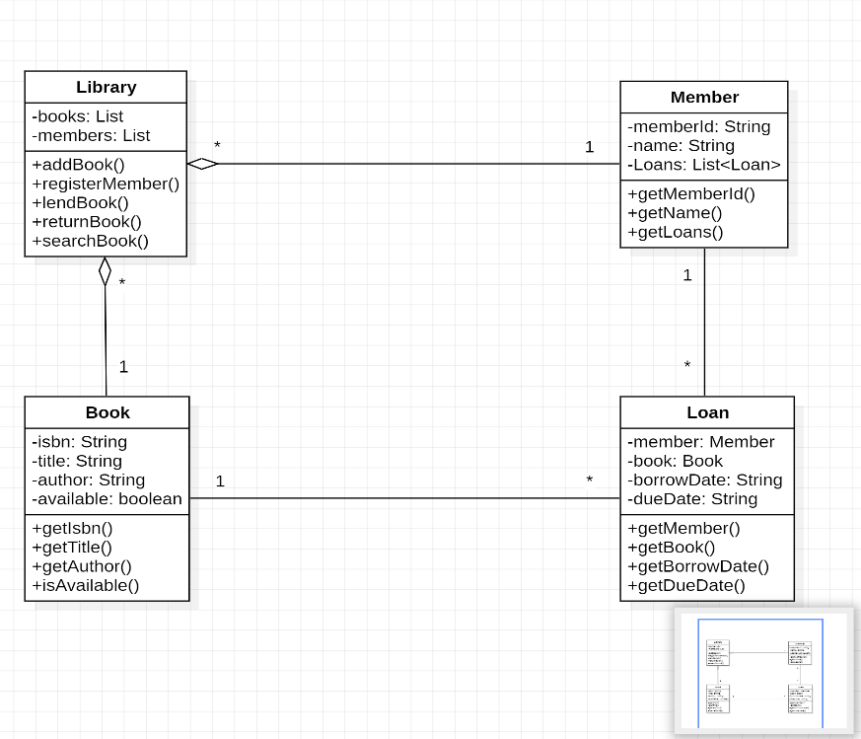
Figure 1: UML Class Diagram for the Library Management System
Part E

(i) Distinguish Association, Aggregation and Composition
Association: Association is a relationship where one class is connected to another class and they can interact with each other. In this library system, a Loan is associated with exactly one Book and exactly one Member. The Loan object links a member to a borrowed book.

Aggregation: Aggregation is a "has-a" relationship where the contained objects can exist independently of the container object. In this design, Library has many Book objects and many Member objects. If the Library object is removed, the Book and Member objects can still exist independently. Therefore, the relationship between Library and Book, and Library and Member, is aggregation.

Composition: Composition is a stronger form of aggregation where the contained object depends on the whole object for its existence. In this design, a Loan exists only when there is a relationship between a Member and a Book. If the loan is removed, that specific borrowing record ceases to exist. Therefore, the relationship involving the Loan record can be considered composition.

(ii) Explain the Multiplicity "1..*" and Give an Example
The multiplicity 1..* means "one or more". It indicates that an object must be associated with at least one related object, but it may be associated with many.
Example from the Diagram
A Member may have 1..* Loan records. This means a member can hold one loan and may also hold multiple loans at the same time, according to the library rules.

